2019 GGCC Final Championship Results
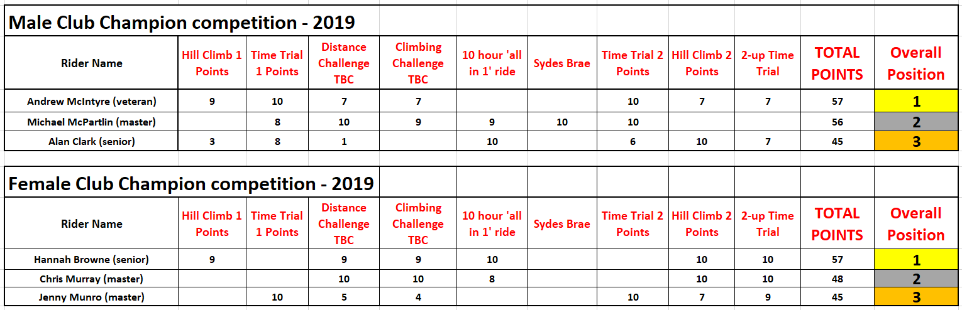
2019 GGCC Final Category Winners
